ILV Mexico Literacy Website Backup
HostGator Control Panel (https://gator4045.hostgator.com:2083/login, Control Panel: Username: ilvmeico, [no ‘x’!], Password: mkvetXXgYO033ACW) (cPanel, Files, Backup)

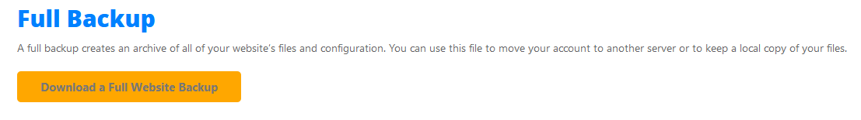
1) Click on this button for backup:
2) Make sure that the following items are checked the click on “Generate Backup”
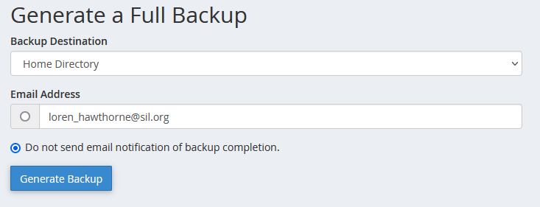
3) When the backup is done click on the most resent one:

4) Save the file.
5) Move the tar.gz file (xplorer² LITE):
D:\Users\Scott\Downloads to Y:\ILVMexico

This contains the PHP scripts (homedir/public-html), data (homedir/public-html/literacy_data), and the ilvmeico_literacy database.

